**MINI PROJECT REPORT**

**ON**

**WE HEAR YOU**

**SUBMITTED IN PARTIAL FULLFILLMENT OF THE REQUIREMENTS OF DEGREE OF**

**BACHELOR OF ENGINEERING**

**BY**

**AYUSH JIVALE**

**SIDDHESH RAVINDRA MHATRE**

**ARYA RATNADEEP PATIL**

**NIRJARA BHANJINAKHAWA**

**SUPERVISOR**

**Prof. PRAJAKTA SHINTRE**



**DEPARTMENT OF INFORMATION TECHNOLOGY**

**PILLAI HOC COLLEGE OF ENGINEERING AND TECHNOLOGY, PILLAI’S HOCL EDUCATIONAL CAMPUS, HOCL COLONY,**

**RASAYANI, TAL: KHALAPUR, DIST RAIGAD 410207**

**UNIVERSITY OF MUMBAI**

**[2024-25]**

 **Mahatma Education Society’s**

**Pillai HOC College of Engineering and Technology,**

**Rasayani-410207**

**2024-25**

**Certificate**

This is to certify that the Mini Project -2 B entitled WE HEAR YOU, a Stress detectoris a bonafide work of **Ayush Jivale** , **Siddhesh Mhatre**, **Arya Patil**, **Nirjara Bhanjinakhawa** submitted to the University of Mumbai in partial fulfilment of the requirement for the award of the degree of **“Undergraduate”** in **“Information Technology”.**

| **_____________________**  **Prof. Poonam Pathak**  (Supervisor) | **________________________**  **Ms. Shibani Bose**  (Project Coordinator) |
| --- | --- |
| **_____________________**  **Prof. Srijita Bhattacharjee**  (Head of Department) | **________________________**  **Dr. J. W. Bakal**  (Principal) |

**Mini Project-2B Report Approval**

This project report entitled “**WE HEAR YOU”** submittedby **Siddhesh Mhatre**, **Ayush Jivale**, **Arya Patil**, **Nirjara Bhanjinakhawa** is approved for the degree of **Bachelor of Engineering in Information Technology**.

**Examiners**

1.

(Internal Examiner)

2.

(External Examine)

**Date:**

**Place:**

**Declaration**

We declare that this written submission represents our ideas in our own words and where others ideas or words have been included. We have adequately cited and referenced the original sources. We also declare that we have adhered to all principles of academic honesty and integrity and have not misrepresented or fabricated or falsified any idea/data/fact/source in our submission. We understand that any violation of the above will because for disciplinary action by the Institute and can also evoke penal action from the sources which have thus not been properly cited or from whom proper permission has not been taken when needed.

| **Siddhesh Mhatre** |
| --- |
| **Ayush Jivale** |
| **Arya Patil** |
| **Nirjara Bhanjinakhawa** |

**Date:**

**Abstract**

In today's fast-paced world, mental health has emerged as a critical concern, particularly in high-pressure environments such as education, the IT industry, and corporate sectors. Stress, if not detected and addressed early, can lead to severe psychological and physical issues. The "WE HEAR YOU" project aims to provide an intelligent, accessible, and user-friendly solution for stress detection using machine learning techniques. This project employs a supervised machine learning model — specifically the Naive Bayes algorithm trained on a dataset related to anxiety, depression, and stress levels. Users interact with the system by answering a series of carefully curated multiple-choice questions, where each option is mapped to a unique recommendation or coping strategy. Based on the user's responses, the model predicts their overall stress level (low, moderate, or high), and a personalized set of suggestions is provided to help them manage their mental well-being effectively. The application is built using Python, Flask (for backend), and HTML/CSS/JavaScript (for frontend). The system includes a user-friendly interface, an admin dashboard for analytics, and a training module with a dataset sourced from Kaggle. The results are displayed visually through a pie chart, offering insights into stress distribution among users. This system bridges the gap between mental health awareness and accessible AI-powered solutions, providing a reliable tool for early stress detection and management.

**Keywords**: Stress Detection, Confusion Matrix, Stress Level Classification, Questionnaire Analysis, Mental Health, Machine Learning

Page | **1**

**List of Figures**

| **Figure**  **No.** | **Figure Name** | **Page No.** |
| --- | --- | --- |
| Figure 4.1 | System Architecture | 13 |
| Figure 5.2 | System Work Flow Diagram |  |
| Figure 6.1 | Home page | 17 |
| Figure 6.2 | Quiz Page | 17 |
| Figure 6.3 | Result Page | 18 |
| Figure 6.4 | Cross Validation Result |  |

Page | **2**

**TABLE OF CONTENTS**

**Content Page No.**

**Abstract 1**

**List of Figures 2**

**1. Introduction 4**

1.1 Background 5

1.2 Motivation 6

**2. Literature Survey 7**

2.1 Basic Terminologies 8

2.2 Existing System 9

2.3 Problem Statement 9

2.4 Objectives 10

**3. Requirement Gathering 11** 3.1 Software and Hardware Requirements 12

**4. Plan of Project 14**

4.1 Proposed System Architecture 15

4.2 Use Cases 16

**5. System Implementation 17**

5.1 Methodology 18

5.2 Work Flow Diagram 19

**6. Result Analysis 20**

6.1 Results and discussion 21

**7. Conclusion 25**

**References 26**

**Chapter 1**

**Introduction**

**Page | 4**

* 1. **Background**

Mental health concerns, particularly stress, anxiety, and depression, are becoming increasingly prevalent in today's fast-paced digital age. Individuals from various domains—students, professionals, and even homemakers—experience stress due to overwhelming workloads, academic pressure, uncertain futures, poor work-life balance, and social challenges. However, identifying and addressing stress early can significantly improve mental well-being and productivity. Traditional stress evaluation often involves clinical interviews, self-assessment scales, or expensive wearable devices that monitor physiological responses. These methods are either inaccessible to many people or require specialized equipment and time-consuming processes. In contrast, advancements in machine learning (ML) and artificial intelligence (AI) offer new opportunities to identify stress patterns using simpler, data-driven approaches. The “WE HEAR YOU” project was designed to provide an interactive, intelligent, and accessible platform for users to assess their stress levels. It enables users to answer a set of structured questions online, after which their responses are processed using a trained Gaussian Naive Bayes model to predict their stress category—Low, Moderate, or High. Additionally, personalized suggestions are provided based on their answers, making the system not just diagnostic but also advisory. This project integrates technology, psychology, and user-centric design to bridge the gap between mental health awareness and accessible digital support.

**Page | 5**

* 1. **Motivation**

The inspiration behind **“WE HEAR YOU”** stems from the desire to create an inclusive, intelligent system that listens to users and responds with empathy and personalized advice. In many societies, mental health is still stigmatized, and people hesitate to seek help. Moreover, not everyone can afford therapy, use wearables, or understand complex self-assessment scales.

We were motivated to solve the following key challenges:

* **Lack of Accessible Tools**: Many individuals are unaware of their stress levels or lack access to digital tools that could help them assess and manage it.
* **Generic Solutions**: Existing applications often offer one-size-fits-all advice, lacking personalization and psychological insight.
* **Stigma & Privacy Concerns**: Users are more willing to interact with anonymous digital systems than speak to others about their emotional state.
* **Data-Driven Empowerment**: Using machine learning allows us to process user inputs meaningfully and provide tailored guidance at scale.

By using a **quiz-based approach**, a **trained ML model**, and an **intelligent suggestion engine**, this project empowers users to take the first step in understanding and managing their stress. It also allows for future scalability and integration into wellness apps, educational systems, and workplace health initiatives.

**Page | 6**

**Chapter 2**

**Literature Survey**

**Page | 7**

* 1. **Basic Terminologies**

To understand the functionality of this project, it’s essential to grasp some of the foundational concepts and technologies involved:

* **Stress**: A physical and psychological response to challenging or threatening situations. It can manifest in emotional, behavioral, or physical symptoms and is classified in this system as **Low**, **Moderate**, or **High**.
* **Machine Learning (ML)**: A subset of artificial intelligence that allows computers to learn from data and make decisions or predictions. This project uses ML to predict stress levels based on user responses.
* **Naive Bayes Algorithm**: A probabilistic ML algorithm based on Bayes' Theorem. It assumes independence between features and is known for its efficiency and effectiveness in text classification and categorical data problems.
* **Gaussian Naive Bayes**: A variant of Naive Bayes used when input features are continuous and normally distributed. It is used in this project to classify stress levels based on questionnaire scores.
* **Scaler (StandardScaler)**: A preprocessing tool that standardizes features by removing the mean and scaling to unit variance. This ensures the ML model treats all features equally.
* **Pickle**: A Python module used for saving and loading trained machine learning models and preprocessors.

**Page | 8**

**2.2 Existing system**

Current stress detection systems generally fall into one of the following categories:

1. **Manual/Clinical Assessment**:
   * Users consult psychologists or counselors and undergo verbal or written stress assessments.
   * While accurate, this is time-consuming, expensive, and inaccessible to many.
2. **Wearable Devices**:
   * Devices like smartwatches measure physiological data (heart rate, sleep cycles, etc.) to estimate stress.
   * These require hardware investment and lack personalization.
3. **Mobile Apps & Online Surveys**:
   * Some mental health apps offer quizzes and meditation content.
   * However, many use static logic with no machine learning, offering generic advice to all users.

**Limitations of Existing Systems:**

* No real-time personalized suggestions based on machine learning.
* Most apps lack accuracy evaluation.
  1. **Problem Statement**

To build an accessible, quiz-based web application powered by a Gaussian Naive Bayes model that collects and analyzes user responses to determine their stress level. Provides personalized recommendations based on each answer, stores data securely for future reference, offers an admin dashboard to monitor model accuracy, user distribution, and suggestion effectiveness. This project aims to empower users with greater insight into their mental well-being through data-driven analysis and real-time suggestions—without requiring professional intervention or wearable devices.

* 1. **Objectives**

1. **Detect Stress Levels Accurately**  
   To build a machine learning model (Naive Bayes) that classifies users into Low, Moderate, or High stress categories based on their responses.
2. **Provide Personalized Recommendations**  
   To generate tailored suggestions for each user depending on their stress level and specific answers.
3. **Limit Quiz Attempts for Data Integrity**To allow a maximum of two quiz attempts per user to ensure data reliability and reduce manipulation.
4. **Support Different User Categories**  
   To make the system usable for students, working professionals, and others by adjusting questionnaire relevance.
5. **Implement a Voting-Based Validation Mechanism**To cross-validate the stress prediction result using a weighted voting algorithm for increased reliability.
6. **Utilize a Balanced and Enhanced Dataset**To preprocess and balance the dataset for improved model performance and accurate classification.

**Page | 10**

**Chapter 3**

**Requirement Gathering**

**Page | 11**

* 1. **Software and Hardware Requirements**

To develop, train, and deploy the **“WE HEAR YOU”** system, the following software and hardware configurations are recommended.

1. **Software Requirements:**

* Operating System: Windows / Linux / macOS
* Python 3.7 or above
* Flask (for web framework)
* SQLite3 (for database)
* Jupyter Notebook or any Python IDE (VS Code, PyCharm)
* Web browser (Chrome, Firefox, Edge, etc.)

1. **Hardware Requirements:**

* A computer or laptop with a minimum of 4 GB RAM (8 GB recommended).
* Processor: Intel i3 or higher (i5/i7 preferred for faster model training).
* Minimum 500 MB of free disk space.
* Stable internet connection for installing dependencies and accessing datasets.

**Page | 12**

1. **Technological Requirements**
2. **Frontend Technologies:**

* HTML5, CSS3, JavaScript (for interactions and visualizations)

1. **Backend Technologies:**

* Python 3.x
* Flask Framework

1. **Database:**

* SQLite3 (lightweight database for storing user data and quiz attempts)

1. **Machine Learning:**

* Naive Bayes Classifier
* scikit-learn (for training and prediction)
* pandas (for data handling and preprocessing)
* numpy (for numerical computations)

1. **Visualization Tools:**

* matplotlib (for pie charts and stress level distribution)

1. **Other Libraries:**

* joblib (for saving and loading ML model)
* flask_sqlalchemy (for database ORM)

**Page | 13**

**Chapter 4**

**Plan of Project**

**Page | 14**

**4.1 Proposed System Architecture**

The proposed system is a web-based machine learning application designed to detect a user's stress level through a structured quiz and deliver personalized recommendations. The system integrates a trained Gaussian Naive Bayes model, a user-friendly frontend interface, a Flask backend for processing logic, and an SQLite3 database to store user data and prediction logs.

The user logs into the system and completes a multiple-choice quiz. Their responses are numerically encoded, standardized using a pre-trained scaler, and fed into the machine learning model. Based on the output (Low, Moderate, or High stress), the system returns both the prediction and personalized suggestions for each response. The results are also stored in the database. An admin dashboard provides a pie chart view of stress level distribution and tracks model accuracy and system usage statistics.

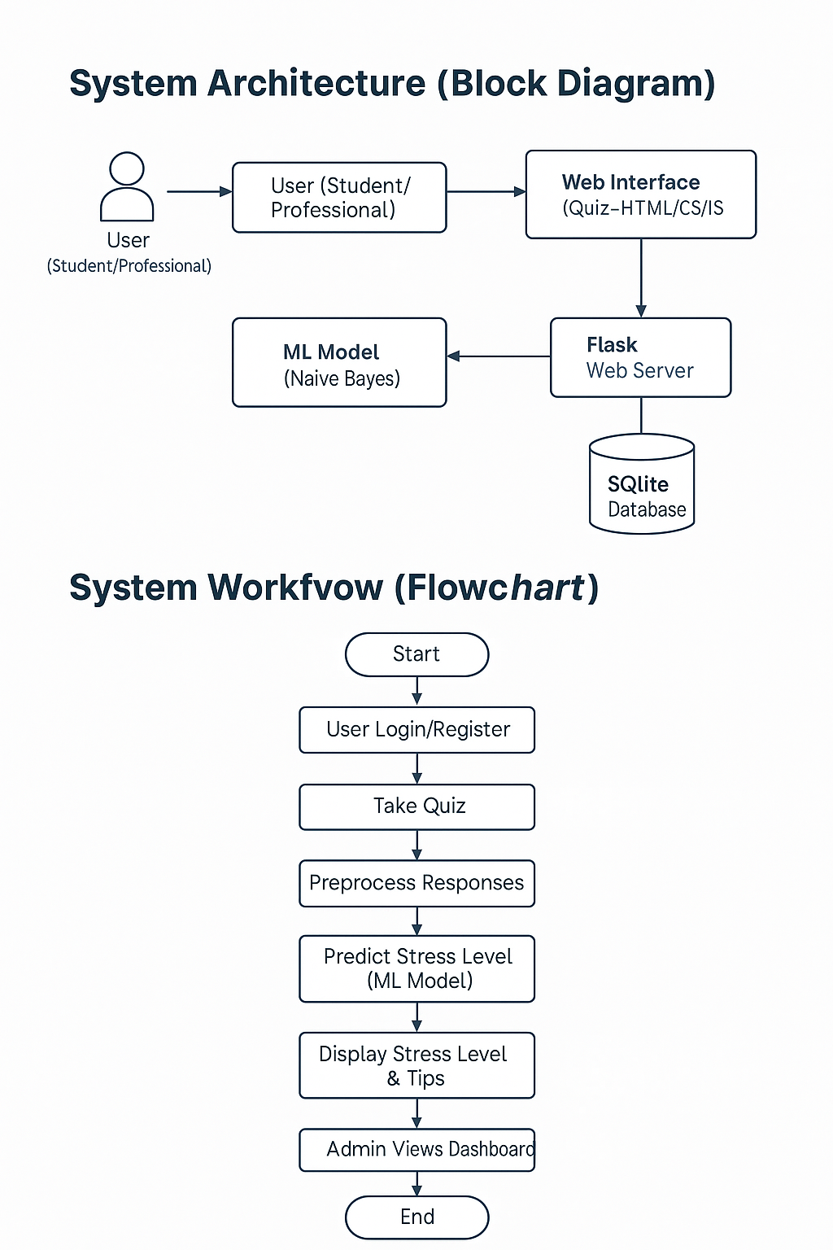

***Figure 4.1: System Architecture***

**Page | 15**

**4.2 Use Cases**

* 1. **Stress Detection for Students**

Students answer a stress-related questionnaire, and the system predicts their stress level using an ML model. Personalized tips help them manage academic pressure and mental health.

* 1. **Stress Detection for Working Professionals**

Professionals take a quiz reflecting workplace challenges. The system provides stress analysis and recommendations to manage burnout, deadlines, or work-life imbalance.

* 1. **Admin Dashboard for Monitoring Trends**

Admins view user stress level statistics, model accuracy, and question-wise performance through a visual dashboard. This helps in identifying common stress patterns.

* 1. **Personalized Recommendation System**

Based on user responses and predicted stress level, the system generates specific suggestions for relaxation, time management, or lifestyle changes.

* 1. **Limited Quiz Access Control**

Each user is allowed only two quiz attempts to maintain result integrity. This ensures honest responses and reliable prediction accuracy.

**Page | 16**

**Chapter 5**

**System Implementation**

**Page | 17**

**5.1 Methodology**

The development of the “WE HEAR YOU” system followed a systematic approach, starting with data collection and ending in real-time user stress prediction and recommendation delivery. The dataset used in this project, stress_data1.csv, was structured to simulate common indicators of psychological stress. It included five key features, each measured on a Likert scale from 0 (Never) to 3 (Often). The target variable was Stress_Level, labeled as Low, Moderate, or High.

Data preprocessing was carried out using Python libraries like pandas and scikit-learn. This included handling any missing data, encoding the categorical inputs numerically, and applying Standard Scaler to normalize all feature values. This step ensured that all features contributed equally during the training phase and that the Gaussian Naive Bayes classifier could operate under the assumption of normally distributed input data. The model was trained using the Gaussian Naive Bayes algorithm, which was chosen for its efficiency and effectiveness in handling small-scale, categorical datasets. The data was split into training and testing sets to evaluate performance.

Prediction and recommendation logic were handled in a separate module, predict_stress.py, which encapsulates the Stress Detection System class. This class loads the trained model and scaler, receives encoded quiz responses from the frontend, performs preprocessing, and predicts the user’s stress level. It also calculates prediction confidence and generates personalized suggestions by mapping each quiz answer to a unique tip using a dictionary-based suggestion engine.

The web application was developed using the Flask framework. The app.py file manages user sessions, routes, and interactions between the frontend and the prediction module. Users access the quiz through a responsive web interface, and upon submission, their responses are evaluated to determine their stress level. The prediction result, confidence percentage, and a compiled set of personalized suggestions are then displayed to the user. These results are also stored in a local SQLite database.

To monitor system performance and usage trends, an admin dashboard was developed. It provides a visual representation of user stress level distribution using pie charts and displays basic usage analytics. This component adds value by offering insights into user behavior and model effectiveness, laying the foundation for future updates and system optimization.

**5.2 System Work Flow Diagram**



***Figure 5.2: System Work Flow Diagram***

**Page | 19**

**Chapter 6**

**Result Analysis**

**Page | 20**

**6.1 Results and Discussion**

The project succeeded in demonstrating that machine learning can be applied meaningfully in the domain of mental health. By using simple, user-friendly interfaces and well-designed backend logic, “WE HEAR YOU” effectively bridges the gap between self-assessment and intelligent mental health support.

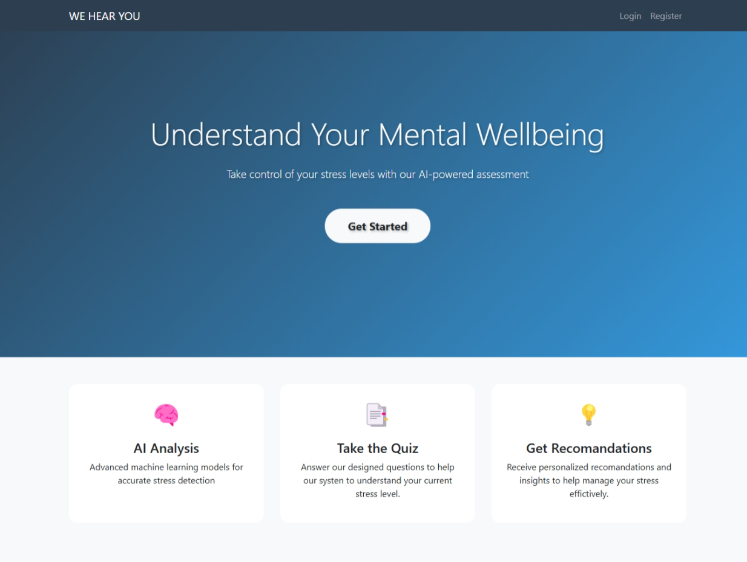

***Figure 6.1: HOME PAGE***

**Page | 21**

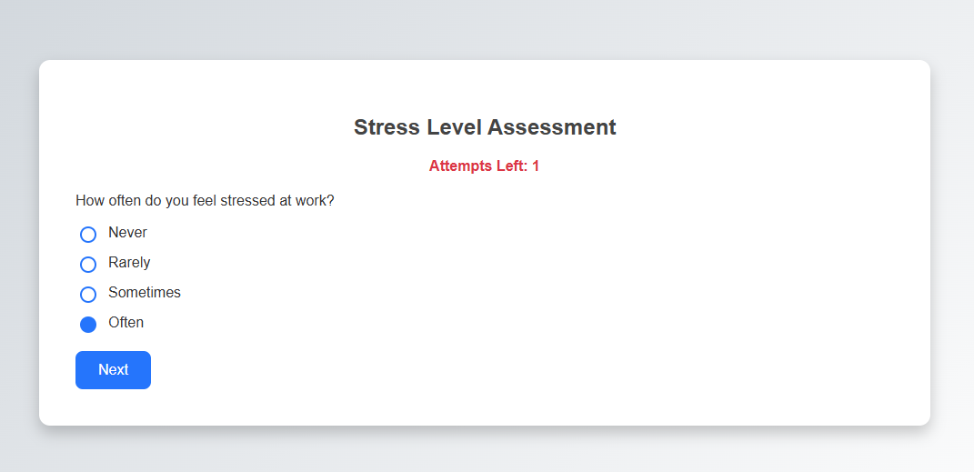

***Figure 6.2: QUIZ PAGE***

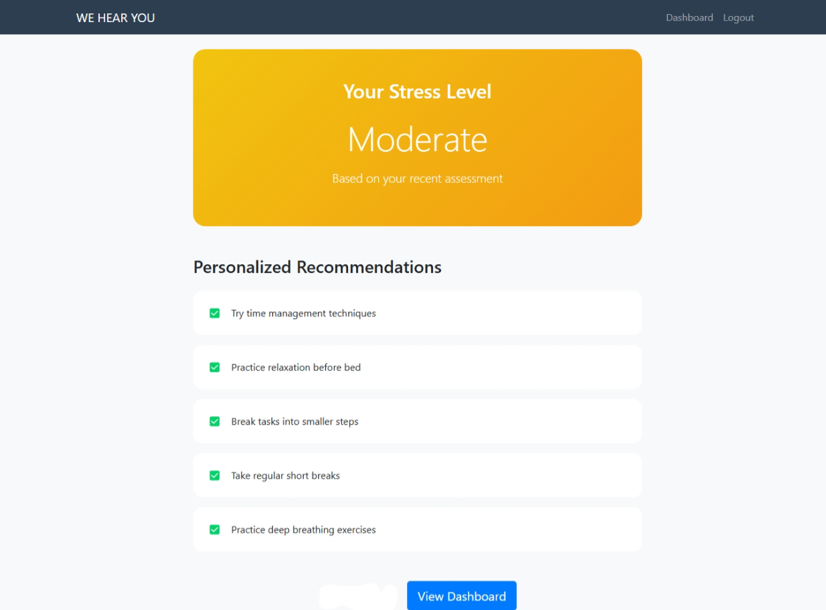

***Figure 6.3: RESULT PAGE***

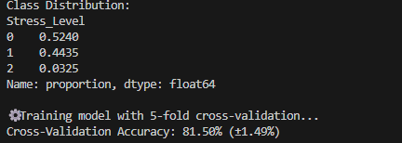



***Fig 6.4 Cross validation Results***

**Page | 23**

**Chapter 7**

**Conclusion**

**Page | 24**

**Conclusion**

The “WE HEAR YOU” mini project successfully demonstrates the use of machine learning in a real-world application focused on mental wellness, specifically stress detection. Through the development of a quiz-based web application powered by a Gaussian Naive Bayes classifier, the project provides users with a convenient and intelligent way to assess their stress levels. The integration of a personalized recommendation engine—where each quiz option maps to a unique tip—further enhances user engagement and ensures that feedback is tailored and actionable. One of the key achievements of this project lies in its simplicity and effectiveness. Using a lightweight technology stack (Python, Flask, SQLite), the system provides accurate predictions and user-friendly interfaces without the need for complex hardware or external APIs. The inclusion of a dynamic admin dashboard allows for monitoring system usage and user stress trends in real time, making it useful not only for individuals but also for educational institutions, organizations, or wellness platforms.

In summary, this project proves that with proper design and implementation, machine learning can be applied ethically and impactfully to support mental health. It lays the groundwork for future enhancements such as real-time feedback loops, chatbot integration, and multilingual support.

**Page | 25**

**References**

1. **Dataset**

* “Anxiety, Depression, and Stress Dataset”  
  Source: [Kaggle – www.kaggle.com](https://www.kaggle.com/)

1. **Naive Bayes Algorithm**

* Scikit-learn Documentation: <https://scikit-learn.org/stable/modules/naive_bayes.html>
* Raschka, S. (2015). *Python Machine Learning*, Packt Publishing.

1. **Mental Health and Stress Data**

* World Health Organization Reports: [https://www.who.int](https://www.who.int/)
* American Psychological Association (APA): [https://www.apa.org](https://www.apa.org/)

1. **Python Libraries & Tools**

* Scikit-learn, Pandas, NumPy, Pickle, Flask: [https://pypi.org](https://pypi.org/)
* Flask Documentation: <https://flask.palletsprojects.com/>

1. **Chart.js** (Used in Admin Dashboard for visualization)

* <https://www.chartjs.org/>

1. **Custom HTML/CSS Design**

* Styled based on user-submitted design references

1. **IEEE Research Paper**  
   T. R. Banu and A. V. Valli,  
   “Mental stress detection using machine learning algorithms,”  
   2019 International Conference on Communication and Signal Processing (ICCSP), Chennai, India, 2019, pp. 1101-1105,  
   doi: [10.1109/ICCSP.2019.8697909](https://doi.org/10.1109/ICCSP.2019.8697909)

**Page | 26**